Case 5-Asia-China-Hongshan-Cloud Shape-Sickle Center-Jade-4700-2900 BCE-15 cm

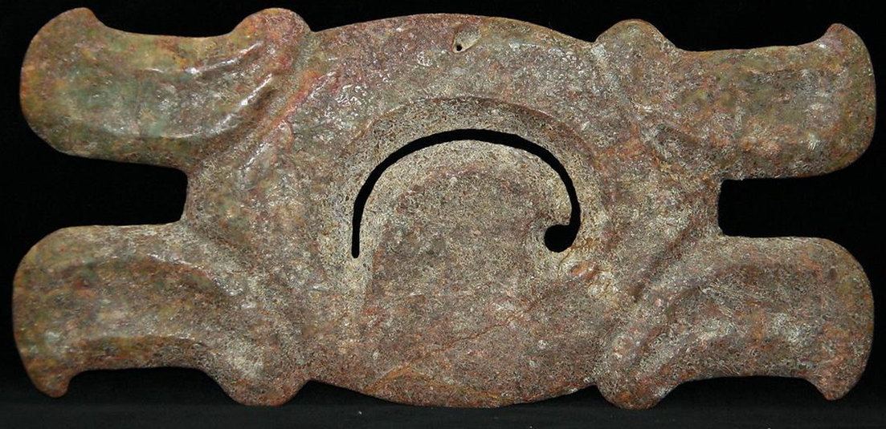

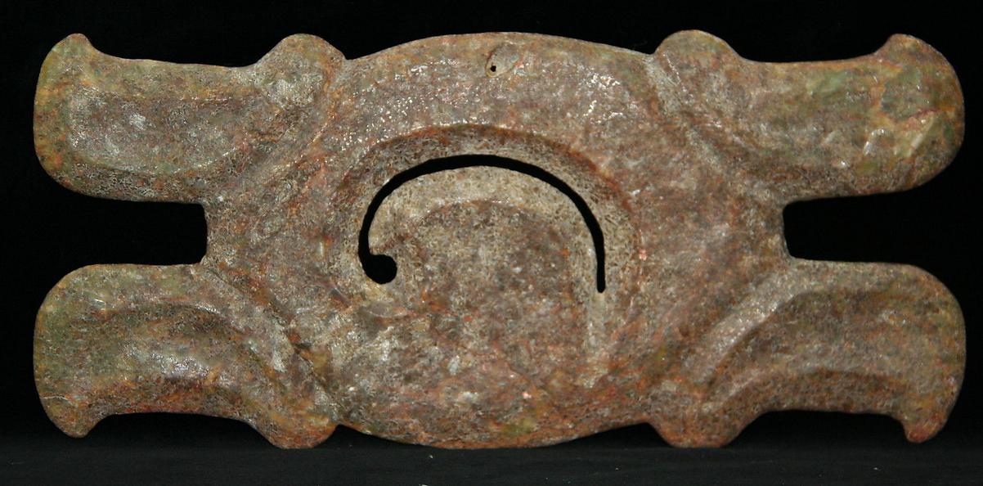

Figs. 1-2. Hongshan-Cloud Shape-Sickle Center-Jade-紅山-雲的形狀-鐮刀中心-玉-4700-2900 BCE-15 cm

Case No.: 5

Accession No.

Formal Label: Hongshan-Cloud Shape-Sickle Center-Jade-紅山-雲的形狀-鐮刀中心-玉-4700-2900 BCE-15 cm

**Display Description:**

The symbolism of this NeolithicHongshan-Cloud Shape-Sickle Center-Jade-紅山-雲的形狀-鐮刀中心-玉is centered on the swirling motion of the clouds as they pivot around the central image of a sickle, which can be right to left or left to right depending on which side of the grooved surface one is viewing. A central pinhole at the top suggests this was used as a pendant. The purpose of this object may be related to shamanism as it was practiced in the Neolithic Hongshan Cultural Period, 4700-2900 BCE.

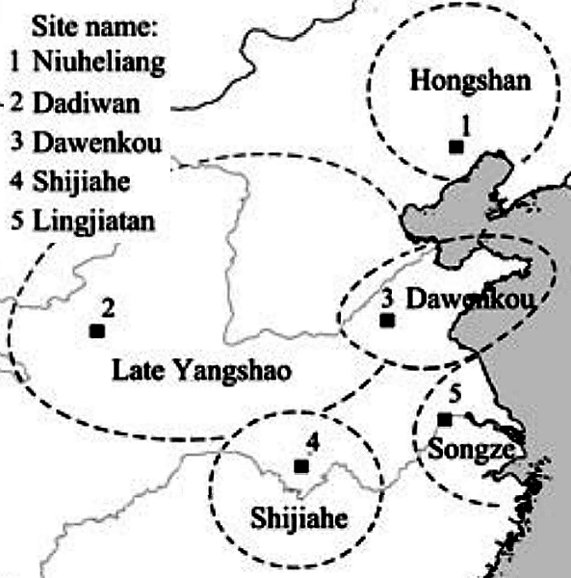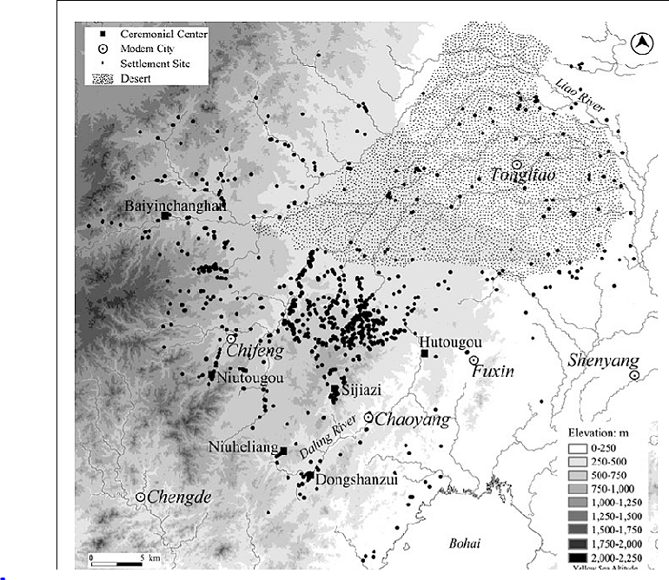

Fig. Five Neolithic Culture zones (4700-2900 BCE) in China associated with ceremonial centers (after Zhang, Bevan Guo 2013).

Fig. Hongshan main ceremonial centers and habitation sites (4700-2900 BCE) (after Zhang, Bevan Guo 2013).

Hongshan domiciles were usually 20–30 m2 circular or square semi-subterranean timber structures with mud daub walls (IMAT 1982; IMPICRA 1994, 2004). Their household economies involved Hongshan economies were shifting from hunting-gathering (deer hunting and wild plant gathering) to a Neolithic economy of millet cultivation and hog husbandry (cf. Zhao 2005; see Guo and Ma 1985).

Hongshan Ceremonial Centers (HCC) include Niuheliang (牛河梁), Dongshanzui (东山嘴), Sijiazi (四家子) and Hutougou (胡头沟) (CBCC and LPICRA 2004; Guo and Zhang 1984; Shao 2004; Fang and Liu 1984),

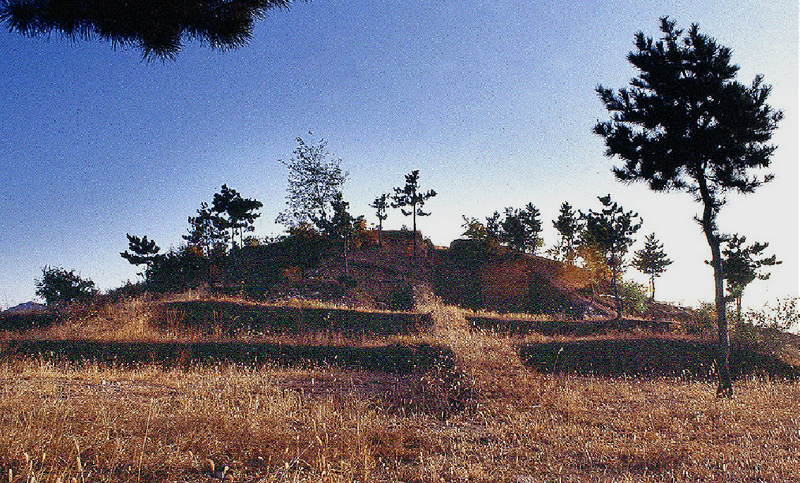

Niuheliang stepped pyramid-shaped building (Site 13) (牛河梁)



Niuheliang ceremonial center (牛河梁禮儀中心)



Niuheliang Site 1, “Goddess temple” 女神廟 aerial view, after <https://gss1.bdstatic.com/-vo3dSag_xI4khGkpoWK1HF6hhy/baike/c0%3Dbaike180%2C5%2C5%2C180%2C60/sign=cc284ad8b83533fae1bb9b7cc9ba967a/a5c27d1ed21b0ef4ce255b88d4c451da80cb3e13.jpg>.



Niuheliang terracotta mask with jade inset eyes. After [https://baike.baidu.com/pic/%E7%89%9B%E6%B2%B3%E6%A2%81%E9%81%97%E5%9D%80/687459/0/0df431adcbef76097944943724dda3cc7dd99ece?fr=lemma&ct=single#aid=0&pic=c83d70cf3bc79f3d3a2527e6b3a1cd11738b2924](https://baike.baidu.com/pic/牛河梁遗址/687459/0/0df431adcbef76097944943724dda3cc7dd99ece?fr=lemma&ct=single" \l "aid=0&pic=c83d70cf3bc79f3d3a2527e6b3a1cd11738b2924)

Niuheliang stepped ceremonial buildings had apical platforms where rituals were presumably performed. Since Hongshan meant “red mountain” some of these structures were built with red igneous stones set into the rammed-earth exterior walls to highlight their heritage. The so-called sunken building, or ‘Goddess Temple’, has clay-plastered walls, some of which are painted in red with geometric designs. The roof was probably arched,

Fractured figurines of various sizes of women, dragons, boars and hawks have been recovered from the ‘Goddess Temple’ (LPICRA 1986; Fig. 6a, b). and behind it is a stone enclosure wall with three altars and large ceramic pots up to 1 m in dia.

was intended for use as a pendant based on the tiny hole in the upper center of this artifact. The symbolism incorporated into these Cloud-Shaped Jades involved the ability to produce a sufficiently thin jade that would permit sunlight to pass through. Secondly, the jade sculptor had to abrade curvilinear concavities that would simulate cloud-like forms. Thirdly, the central image of these Cloud-Shaped Jades is a hooked motif in the center that pivots the swirling nature of clouds in motion. The central visual theme is, therefore, a curvilinear Heaven (霄, Xiao) or Firmament (苍穹, Cāngqióng), that concretizes the evanescent and transitory nature of clouds as permanent an entity as is comparable the rectilinear structures of solid Earth.

Neolithic Hongshan culture 4700-2900 BCE (紅山文化; pinyin: Hóngshān wénhuà) extended from Inner Mongolia to Liaoning and is named after Hongshanhou (: 紅山後; pinyin: Hóngshānhòu), a site in Hongshan District, [Chifeng](https://en.wikipedia.org/wiki/Chifeng), that was discovered by Japanese archaeologist Torii Ryūzō in 1908 and excavated in 1935 by Kōsaku Hamada and Mizuno Seiichi (Hamada and Seiichi 1938). Chifeng (赤峰市), also known as Ulankhad (Mongolian: ᠤᠯᠠᠭᠠᠨᠬᠠᠳᠠ ᠬᠣᠲᠠ (Улаанхад хот) Ulaɣanqada qota [ʊlaːnxad xɔt], "red cliff"), has a Neolithic cultural history that can be traced back nearly eight thousand years. Representative ruins and relics of Hongshan Culture, Grassland Bronze Culture, Qindan Nationality-Liao Culture and Mongolian-Yuan Culture have been discovered in Chifeng. The ruins of an ancient village, named Xinglongwa, are regarded as “the first village of China” by historians. The biggest jade dragon unearthed in the area is known as “the first dragon of China”. The discovery of ruins and relics of ancient cultures have come from more than 6,800 sites. Named after Chifeng's Hongshan District ([42°15′55″N 118°57′34″E](https://tools.wmflabs.org/geohack/geohack.php?pagename=Hongshan_District,_Chifeng&params=42_15_55_N_118_57_34_E_region:CN-15_type:city)), Hongshan Culture was a Neolithic culture in northeastern China, whose sites have been found mainly in Chifeng, and dated from about 4700 to 2900 BCE.

Accession Number:

LC Classification:

Date or Time Horizon:

Geographical Area:

Map:

GPS coordinates:

The Niuheliang Archaeological Site: N 41°16′15″ , E 119°27′9″

The Hongshanhou Archaeological Site: N 42° 19′ 19″ , E 118° 59 ′29″

The Weijiawopu Archaeological Site: N 42 °08′ 24.6″ , E 118° 57′ 41.3″

Cultural Affiliation: Hongshan

Medium: jade

Dimensions: width 15 cm., height 2.5 cm., thickness 1.3 cm.

Weight:

Condition: original

Provenance:

Discussion:

Hongshan culture has three representative sites of the Hongshan culture: Niuheliang, Hongshanhou and Weijiawopu (UNESCO 2017).

The Niuheliang Archaeological Site was a burial and sacrificial center in the late Hongshan period. Compared with other late Hongshan sites so far known, it boasts the greatest scale, the best preservation, the richest varieties of remains, and the largest number of unearthed cultural relics.

The Hongshanhou and Weijiawopu Archaeological Sites, dating back to 6,000-5,500 years ago, were both residential settlements. While the Weijiawopu is a site with the largest number of discovered residential structures, the Hongshanhou Site is the place after which the Hongshan culture was named. In spite of different functions and types of the three sites, they have internal and reciprocal relationships, with which people’s production, lifestyle, burial and sacrificial activities of the Hongshan culture period are found.

*Niuheliang was excavated by the Liaoning Provincial Archaeological Research Institute in the mid-1980s in the* rolling hills of north-eastern China, near the Inner Mongolian border of Liaoning province, a 502 km Neolithic landscape opposite a low mountain shaped like a sleeping animal. Local villagers call this hogback range 'Mù liè'shān ('木列'山, 'Columns of Tree Mountain), but regional archaeologists bestowed upon it the name of **'**BoarMountain**'** after discovering a Neolithic complex across the basinwhich suggests this mountainwas recognized in antiquity and celebrated as a sacred boar. The Neolithic remains of this mountain complex have yielded so-called 'boar-dragon' jades and a clay sculpture of a boar's mandible that combines a ritual complex of aboarand amountain**.**

 I The Niuheliang Archaeological Site

The Niuheliang Archaeological site is located at the border of Lingyuan City, Jianping County, and Harqin Left Wing Mongol Autonomous County under the jurisdiction of Chaoyang City, Liaoning Province. As an area with foothills located between the Mongolian Plateau and the offshore zone of the North China Plain, the site is naturally composed of a number of mountain valleys with a northeast-southwest direction, ridges between the valleys, and a natural setting formed by the Nuluerhu Mountains, an extension of the Great Khingan Range. The altitude of Niuheliang ranges between 550 meters and 680 meters, and the archaeological spots are mainly distributed on the hilltop of the mountain ridges.

In  1981,  Liaoning  Province  started  the  second  cultural  relics  survey,  and  16 Archaeological spots were discovered and numbered. Between 1983 and 2003, the Liaoning Institute of Cultural Relics and Archaeology undertook a series of large excavations at Spots No. 2, 3, 5, and 16, and the sites of Hongshan culture within Niuheliang Archaeological Site were divided into the following six categories: the Goddess Temple, the platform, the stone mound, the sacrificial altar, the building foundation, and the cellar. Within an area of 50 square kilometers at Niuheliang Site, no residential settlements have been discovered so far, which indicates that the sacrificial center had been separated from the residential zones then, and the site served as a separate place particularly   reserved   for   constructions   of   temples,   graves   and   cemeteries.   In   this   sense,   the   Niuheliang Archaeological Site is an outstanding example of “holy sacrificial land” of the early period of human civilization so far discovered in Northeast Asia, and boasts the largest scale, the highest rank, and the most prominent expression of beliefs.

The Goddess Temple comprises the temple ruins and its northern platform, surrounded by several sacrificial pits. The temple ruins are semi-subterranean earth-wood structures, composed of a set of interconnected chambers and a single chamber in the south. It measures 25 meters long from north to south, 2 to 9 meters wide from east to west, and covers an area of 75 square meters. Parts of six individual clay figures were unearthed during preliminary excavations, including one life-size statue of human head. All the statues are exquisitely made with female features, being regarded as statues of female ancestors who were worshiped. In addition, animal-shaped sculptures and sacrificial potteries were unearthed at the Goddess Temple. In general, the Goddess Temple reflects an embryonic form of the ancestral temple, and it is hitherto one of the earliest sacrificial temples discovered in the whole region of Northeast Asia.

There are 14 stone mounds discovered on the hilltops within Niuheliang Site. Each hill may have a single grave, double graves, or multiple graves. Given the scale, structural form, type and quantity of burial objects, the graves fall into four categories. First, a large grave is located at the center, dominating the other graves. This central grave, spaciously constructed, is deeply anchored into its rock foundation. A stone coffin, whose inner wall is neatly constructed, contains a variety of jade articles without other burial objects such as potteries and stone objects. The second-level graves are large-scale stone coffins, deeply anchored in rock foundation. Some coffins have steps at one side of the grave wall. The coffin is spacious and neatly constructed, with jade articles buried inside only. The third- level graves are constituted by regular stone coffins, constructed with slates or stone blocks, along with a few jade articles buried inside. Lastly, the small-scale stone graves have no burial artifacts inside. In this way, the Niuheliang Archeological Site is a large cluster of prehistoric burial sites, featuring a clear internal hierarchical order and system. Jade artifacts were made in shapes of dragon, phoenix, tortoise, and human beings, and most graves had only jade artifacts inside, which indicates a distinctive prehistoric convention - “buried exclusively with jade articles” and marks the first heyday in development of jade culture during the prehistoric period of China. The emergence of the central grave manifests social differentiation featuring “the supreme power of one person” in the late period of Hongshan culture, and fully reflects the privileged status of the owner of the central grave. In both scale and magnificence, the central grave is equivalent of emperors’ mausoleums of the following periods.

Altars are located next to the stone mounds. Until now, two altars have been discovered, namely, a round altar at Spot No. 2 and a square altar at Spot No. 5. The former is symbolically significant in terms of its plan arrangement, composition, and construction materials. To be specific, it has a nearly circular plan, comprising a three-layered Altar Border and a set of piled stones at its center. The Altar Border is constructed with standing stones arranged in order, which form three concentric circles. Gradually higher from outside to inside, they establish the foundation and make the outline of the altar. Besides, rows of canister-shaped potteries are placed right next to the standing stones. In the center of the inner circle of the altar, there are piled stones. In addition to this unique formation, the piled stones are distinctive  for  they  are smaller  than  those  of other  stone  mounds  and  they  are  of complex  varieties  of rocks. Resembling the sacrificial altars in later times that are used to worship Heaven and Earth, the architectural form of altars at Niuheliang is widely believed to be a significant exemplar of embryonic altars in China and even Northeast Asia.

 II The Hongshanhou Archaeological Site

The Hongshan Mountain is located on the bank of the Yingjin River, northeast of Chifeng City, Inner Mongolia Autonomous Region. The mountain covers an area of 10 square kilometers; and it comprises 9 peaks, among which the main peak is 746 meters above sea level. The Hongshanhou settlement site lies on the southeast slope of the secondary peak, and covers an area of roughly 20,000 square meters. The site was firstly excavated by Japanese in 1935, during which semi-subterranean house ruins and ash pits were discovered, with a large number of cultural relics including potteries, stone artifacts, and bone-made artifacts. The excavation of the Hongshanhou Site for the first time revealed the state of prehistoric human production and lifestyle in the West Liao River Basin 6,000 – 5,500 years ago. Furthermore, the Hongshan culture is named after the Hongshanhou Archaeological Site, and it laid one of the foundations for the Chinese civilization, revealed by series of major archaeological discoveries in later times.

III The Weijiawopu Archaeological Site

The Weijiawopu Archaeological Site is located south of Hongshan District, Chifeng City, Inner Mongolia Autonomous Region, 20 kilometers away from downtown Chifeng City. The site is located on a relatively flat platform, and covers an area of 93,000 square meters in total. In May 2008, based on pottery samples collected on surface of the site, archaeologists confirmed that the site used to be a large settlement cluster during the Hongshan culture period. Between 2009 and 2011, a joint archaeology  team consisting of the Inner Mongolia Institute of Cultural Relics and Archaeology and the Frontier Archaeology Center of Jilin University officially carried out archaeological  excavations  at  this  site,  and  discovered  103  semi-subterranean  house  remains,  201  cellars  and sacrificial pits, as well as well-preserved trenches. Dating back to 6,000 – 5,500 years ago, the Weijiawopu site is a large-scale settlement cluster that is best preserved and contains the richest varieties and the largest number of unearthed cultural relics, including residential ruins, cellars, sacrificial pits, and trenches.

The discovery and excavations of the Weijiawopu site have supplied rich materials for the study of settlement forms of the Hongshan culture period. The materials are also academically invaluable for the research of the population, society, lifestyle, and human-nature relation during the period. The Weijiawopu Archaeological Site is a relatively high-level residential ensemble with a large size and a great number of well-arranged residential houses. Being settled down, inhabitants of the Hongshan culture developed an advanced agriculture, revealed by the large number of tools for the production. Foods were also provided by hunting, gathering, and fishing. Family became the primarily social unit. In addition, handicraft became increasingly professionalized. In particular, pottery-making was highly developed. Painted pottery characteristic of the Central Plains of China was introduced and widely used. Openness and fusion were the major factor that stimulated the rapid development of Hongshan culture.

Centered at the Goddess Temple, surrounded by altars and stone mounds, the Niuheliang Archaeological Site is a magnificent prehistoric burial and ceremonial area, separated from residential settlements. Dating back to 5,500-5,000 years ago, it was a sanctuary where ancestors of the Hongshan people were buried and sacrifices were offered to ancestors, Heaven and Earth. As a reflection of a primitive state combined both theocratic and royal powers, the Niuheliang Site bears a witness to the origin of the civilization of Northeast China and even Northeast Asia. The abundant physical remains and cultural information contained in the site are of outstanding value for the study of prehistory, archaeology, anthropology, philosophy, and aesthetics.

The Hongshanhou Site, where the Hongshan inhabitants settled and lived 6,000-5,500 years ago, nestles in the Hongshan Mountain, where prehistoric villages and natural landscapes are well integrated. It boasts rich cultural connotation and bears two different cultural elements of the Neolithic Age from the Central Plains and north China, thus becoming the origin after which the Hongshan culture was named and occupying an important status in Chinese archaeological history.

The Weijiawopu Site is a large-scale settlement ensemble distributed around the Hongshan Mountain. The semi- subterranean houses were constructed with standing wood columns. This kind of structure was being employed for a great period of time in Northeast China because of a neat advantage - warm in winter and cool in summer. Moreover, the well-ordered and trenched houses represent a sophisticate system of social organization and management. The site featured a diversified economic structure, dominated by farming which was complemented by fishing, hunting, and gathering. For farming, the most primary unit for grain production is the family; for hunting, however, families had to maintain close cooperation between each other.

Prehistoric symbolism as it was incorporated in jade artifacts was integrated with Chinese cosmology 6,000 years ago. Hongshan people created an integral and unique religious system, involving ancestor worship, shamanistic spirituality, and cosmologies that linked Heaven and Earth, all of which were illuminated by jade artifacts that served as the main medium of communication between the human and divine worlds.

References:

Dashun Guo. 1997. Understanding the burial rites of the Hongshan culture through jade. In Rosemary E. Scott, ed., Chinese Jades. Colloquies on Art and Archaeology in Asia, no. 18. Percival David Foundation of Chinese Art. London: School of Oriental and African Studies, University of London, pp. 27-36.

Hamada, Kosaku and Mizuno Seiichi. "Chifeng Hongshanhou," Archaeologia Orientalis, ser. A, No. 6. Far-Eastern Archaeology Society of Japan, (1938).

Institute of Archaeology in Liaoning. 1986. Excavation of the deity temple and a cluster of stone heaped tombs of Hongshan Culture at Niuheliang in Liaoning, Wenwu 8: 1-17.

UNESCO. 2017. Sites of Hongshan Culture: The Niuheliang Archaeological Site, the Hongshanhou Archaeological Site, and Weijiawopu Archaeological Site. http://whc.unesco.org/en/tentativelists/5804/

SHAPE \* MERGEFORMAT 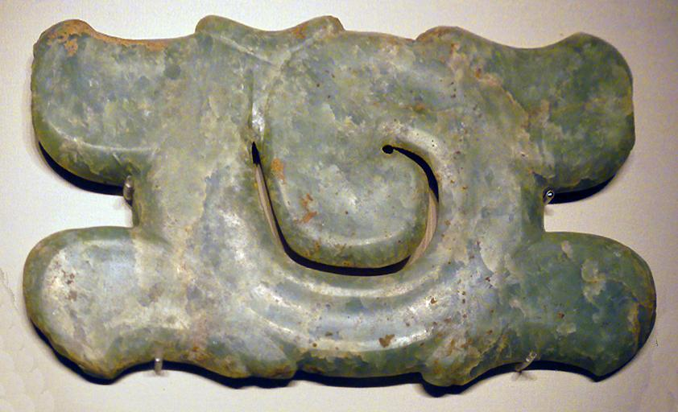Hook-and-cloud Jade Ornament, Hongshan Culture (c. 4700-2900 BC), unearthed at niuheliang, Lingyuan, Hooked, cloud-shaped pendant, tomb 521 M1, Liaoning Province, 1987, exhibited in the section of Life and Production in Neolithic China, an exhibition of Ancient China in the National Museum of China, Beijing. (Source: China.org.cn).

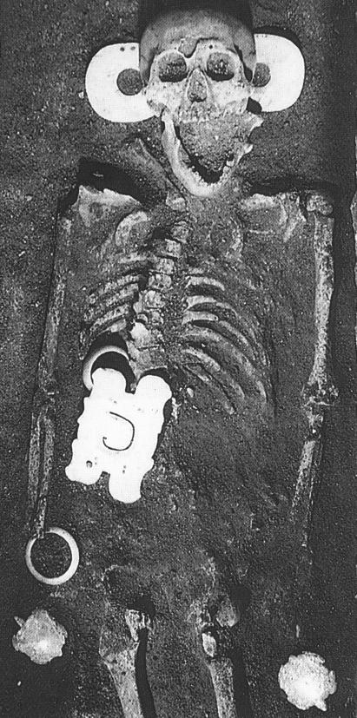

The position of the hooked, cloud-shaped pendant (together with two doubly perforated jade bi disks, two jade bracelets and two jade soft shell turtles) in the large central tomb at Niuheliang site, locality 5, cairn 1, 521 M1 after Dashun 1997, Plate 3.

REFERENCES

